EETC 2351 Data Acquisition & Control
LAB 3 Math calculations

Purpose: The purpose of this exercise is to expose the student to Math Functions and their operations.

Procedure:
- Two primary factors influence the distance a baseball can travel once it is struck by a bat assuming no tail or head wind blowing, (1) the angle at which the ball leaves the bat and (2) the velocity at which the ball leaves the bat. Using the angle at which the ball leaves the bat in degrees as input A and the velocity at which the ball leaves the bat in feet/sec as input B, develop a VI which will compute the distance that the baseball will travel in feet. The equation of motion is given below:
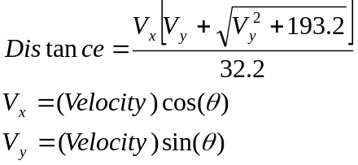
a. Create a New VI.
b. Add two Numeric Controls to the Front Panel Display. Label one VELOCITY in ft/s and the other ANGLE in degrees.
c. Add one Numeric Indicator to the Front Panel Display. Label this indicator DISTANCE in feet.
d. Develop a block diagram to implement the equations above. Since the sine and cosine functions in LabVIEW utilize radians, then you will have to convert the numeric control from degrees to radians, i.e., π radians = 180º.
f. Test the system using the following inputs:

Velocity = 100 ft/s
Angle = 30º
Distance = 274 ft

Velocity = 120 ft/s
Angle = 45º
Distance = 450 ft

- Create a new VI that accepts the radius of a circle as an input in inches and computes Circumference (2πr), the Diameter (2r) and the Area (πr²). Display each of the results on the Front Panel. If the Circumference is less than the area, then turn on a green LED; if the Circumference is equal to the area, then turn on a Yellow LED; if the circumference is greater than the area, then turn on a RED LED.

